

PLANO DE AULA
Aula 15 | Tempo estimado: 1 hora e 30 minutos | Faixa-Etária: Game Advanced
Tipo da atividade: No computador
Ferramenta(s): Unity 3D

Conteúdos
- Sistema de Armas - Parte 3

Objetivos
- Implementar o sistema de armas..

Estratégias e atividades

Para dar continuidade ao sistema de armas que iniciamos nas aulas anteriores, vamos agora implementar a integração completa no script do Player. Nesta terceira parte, vamos adicionar a mecânica de troca de armas, o sistema de mira (aim) e a lógica de disparo, fazendo com que todas as funcionalidades de armamento desenvolvidas até aqui funcionem de forma integrada com o movimento e combate do personagem.

START

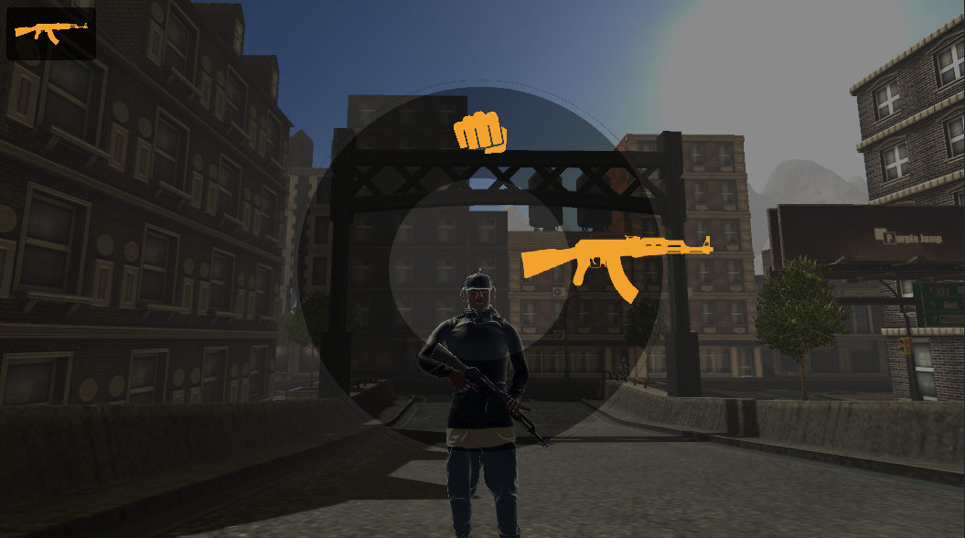
Vamos alterar o script do player:

using System;
using System.Collections;
using System.Collections.Generic;
using System.ComponentModel.Design;
using System.Threading;
using Cinemachine;
using JetBrains.Annotations;
using TMPro;
using Unity.VisualScripting;
using UnityEngine;
using UnityEngine.Animations.Rigging;
using UnityEngine.EventSystems;
using UnityEngine.InputSystem;
using UnityEngine.TextCore.Text;
using UnityEngine.UI;
using static Cinemachine.CinemachineFreeLook;
using static NPC;

public class Player : MonoBehaviour
{
public enum PlayerState
{
Passive,
Agressive,
Equipped,
Dead
}

public enum CurrentWeapon
{
Hand,
Assault,
}

[Header("Player Status")]
public PlayerState state;
public float health;
public bool isHit;
public bool isDead;

[Header("Movement")]
public float playerSpeed;
public float playerSprint;
public float currentSpeed;
public float smoothSpeed;
public float jumpRange;
Vector3 velocity;

[Header("Animation")]
public CharacterController playerController;
public RuntimeAnimatorController animController;
public RuntimeAnimatorController combatController;
public RuntimeAnimatorController equippedController;
public Animator anim;

[Header("Combat")]
public List<GameObject> enemyGroup;
public GameObject enemyFocus;
public bool isAttacking;
public float timeAttack;
public int attackCount;
public float damage;

[Header("Equipped")]
public bool playerAim;
public Rig aimRig;
public float rigWeight;

[Header("Weapon")]
public GameObject changeWeaponPanel;
public bool changeWeapon;
public Weapons weapons;
public CurrentWeapon currentWeapon;
public Transform weaponSlot;

[Header("Camera")]
public Transform camTransform;
public Transform headTransform;
public Transform targetTransform;
public LayerMask targetMask;
public CinemachineFreeLook freeLookCam;
public CinemachineFreeLook combatCam;
public Cinemachine3rdPersonAim aimCam;
public float turnSmoothTime;
float turnSmoothVelocity;

[Header("Gravity")]
public Transform surfaceCheck;
public LayerMask surfaceMask;
public float surfaceDistance;
public float gravity;
public bool onSurface;

[Header("Input")]
public Controls controls;

private void Awake()
{
UnityEngine.Cursor.visible = false;
UnityEngine.Cursor.lockState = CursorLockMode.Locked;
controls = new Controls();
controls.Enable();
}

void Start()
{
playerSpeed = 2f;
playerSprint = 5f;
smoothSpeed = 10f;
currentSpeed = 0f;
isAttacking = false;
isDead = false;
timeAttack = 1f;
attackCount = 0;
damage = 20f;
jumpRange = 0.5f;
playerAim = false;
rigWeight = 0f;
turnSmoothTime = 0.1f;
surfaceDistance = 0.4f;
enemyFocus = null;
gravity = -9.8f;

weapons = GetComponent<Weapons>();
}

void FixedUpdate()
{
if (!isDead)
{
Gravity();

if(controls.Player.ChangeState.triggered)
{
AlternateState();
}

if (controls.Equipped.ChangeWeapon.IsPressed())
{
changeWeapon = true;
changeWeaponPanel.SetActive(true);
Time.timeScale = 0.1f;

float inputX = controls.Player.Camera.ReadValue<Vector2>().x;
float inputY = controls.Player.Camera.ReadValue<Vector2>().y;

weapons.SetActiveSlot(inputX, inputY);

if(weapons.currentWeapon != Weapon.weaponName.Hand)
{
state = PlayerState.Equipped;
}
else
{
state = PlayerState.Passive;
}

freeLookCam.m_XAxis.m_MaxSpeed = 0f;
freeLookCam.m_YAxis.m_MaxSpeed = 0f;
}
else
{
changeWeapon = false;
changeWeaponPanel.SetActive(false);
Time.timeScale = 1f;

freeLookCam.m_XAxis.m_MaxSpeed = 300f;
freeLookCam.m_YAxis.m_MaxSpeed = 2f;
}

switch (state)
{
case PlayerState.Passive:

isAttacking = false;
isHit = false;
anim.runtimeAnimatorController = animController;
combatCam.Priority = 8;

Move();
Jump();

break;
case PlayerState.Agressive:

anim.runtimeAnimatorController = combatController;
combatCam.Priority = 11;

Move();
Combat();

break;
case PlayerState.Equipped:

anim.runtimeAnimatorController = equippedController;

Move();
Equipped();

break;
case PlayerState.Dead:

Die();

break;
}
}
else
{
anim.SetBool("isDead", true);
combatCam.gameObject.SetActive(false);
freeLookCam.gameObject.SetActive(true);
}
}

public void Equipped()
{
float maxDistance = 100f;
RaycastHit hit;

aimRig.weight = Mathf.Lerp(aimRig.weight, rigWeight, turnSmoothTime);

if (Physics.Raycast(camTransform.position,camTransform.forward, out hit, maxDistance, targetMask))
{
targetTransform.position = hit.point;
}
else
{
targetTransform.position = camTransform.position + camTransform.forward * maxDistance;
}

if (controls.Equipped.Aim.ReadValue<float>() > 0)
{
freeLookCam.Priority = 8;
freeLookCam.transform.rotation = Quaternion.LookRotation(transform.forward);

playerAim = true;
rigWeight = 1f;
anim.SetBool("Aim", true);
}
else
{
freeLookCam.Priority = 10;

if (playerAim)
{
freeLookCam.transform.rotation = Quaternion.LookRotation(transform.forward);
}

playerAim = false;

rigWeight = 0f;
anim.SetBool("Aim", false);
}

if(playerAim && controls.Equipped.Shoot.ReadValue<float>() > 0)
{
weapons.Shoot(hit);
}
}

private void Gravity()
{
//Checagem do Player em uma Superfície
onSurface = Physics.CheckSphere(surfaceCheck.position, surfaceDistance, surfaceMask);

if (onSurface && velocity.y < 0)
{
velocity.y = -2f;
}

//Gravidade
velocity.y += gravity * Time.deltaTime;
playerController.Move(playerSpeed * Time.deltaTime * velocity.normalized);

anim.SetBool("OnSurface", onSurface);
}

public void AlternateState()
{
if (!isAttacking && !isHit)
{
if (state == PlayerState.Passive && enemyGroup.Count > 0)
{
state = PlayerState.Agressive;
SetEnemyFocus();
}
else if (state == PlayerState.Agressive)
{
state = PlayerState.Passive;
}
}
}

private void Move()
{
float inputX = controls.Player.Move.ReadValue<Vector2>().x;
float inputZ = controls.Player.Move.ReadValue<Vector2>().y;
float moveSpeed;

Vector3 direction = new Vector3(inputX, 0, inputZ).normalized;
float targetAngle = Mathf.Atan2(direction.x, direction.z) * Mathf.Rad2Deg + camTransform.eulerAngles.y;
float angle = Mathf.SmoothDampAngle(transform.eulerAngles.y, targetAngle, ref turnSmoothVelocity, turnSmoothTime);

if (state == PlayerState.Equipped && playerAim)
{
Vector2 inputY = controls.Player.Camera.ReadValue<Vector2>();

float newRotationX = headTransform.localEulerAngles.x - inputY.y;

if (newRotationX > 180)
newRotationX -= 360;
newRotationX = Mathf.Clamp(newRotationX, -80f, 80f);

transform.eulerAngles += new Vector3(0f, inputY.x, 0f);
headTransform.localEulerAngles = new Vector3(newRotationX, headTransform.localEulerAngles.y, headTransform.localEulerAngles.z);
}
else
{
headTransform.localEulerAngles = new Vector3(Mathf.Lerp(headTransform.localEulerAngles.x, 0f, smoothSpeed), headTransform.localEulerAngles.y, headTransform.localEulerAngles.z);
transform.rotation = direction.magnitude >= 0.1f ? Quaternion.Euler(0f, angle, 0f) : transform.rotation;
}

if (direction.magnitude >= 0.1f && onSurface && !isAttacking && !isHit)
{
Vector3 moveDirection = Quaternion.Euler(0f, targetAngle, 0f) * Vector3.forward;

float targetSpeed = controls.Player.Run.IsPressed() && !playerAim ? playerSprint : playerSpeed;
currentSpeed = Mathf.Lerp(currentSpeed, targetSpeed, Time.deltaTime * smoothSpeed);

playerController.Move(currentSpeed * Time.deltaTime * moveDirection.normalized);
jumpRange = 0f;
}
else if(direction.magnitude < 0.1f)
{
currentSpeed = Mathf.Lerp(currentSpeed, 0f, Time.deltaTime * smoothSpeed);
jumpRange = 0.5f;
}

if (state == PlayerState.Agressive || playerAim)
{
anim.SetFloat("inputX", direction.x);
anim.SetFloat("inputZ", direction.z);
}

moveSpeed = new Vector3(playerController.velocity.x, 0f, playerController.velocity.z).magnitude;
anim.SetFloat("Velocity", moveSpeed);
}

public void SetEnemyFocus()
{
foreach (GameObject enemy in enemyGroup)
{
if (enemy.GetComponent<NPC>().isDead)
{
enemyGroup.Remove(enemy);
}
else if (enemyFocus == null)
{
enemyFocus = enemy;
}

if (enemyGroup.Count > 0)
{
if (Vector3.Distance(transform.position, enemy.transform.position) < Vector3.Distance(transform.position, enemyFocus.transform.position))
{
enemyFocus = enemy;
}
}
}
}

public void Combat()
{
if (enemyFocus != null)
{
Vector3 target = new(enemyFocus.transform.position.x, transform.position.y, enemyFocus.transform.position.z);

if (enemyGroup.Count > 0)
{
if (enemyFocus.GetComponent<NPC>().isAgressive)
{
transform.LookAt(target);
}
}
else
{
Invoke("AlternateState", 2f);
}
}

if (controls.Player.Attack.triggered && !isHit)
{
isAttacking = true;
anim.SetTrigger("Attack");
}
}

public void HitDamage(float damage)
{
health -= damage;

if (health <= 0f)
{
state = PlayerState.Dead;
return;
}
else
{
isHit = true;
anim.SetTrigger("Hit");
}
}

private void OnTriggerEnter(Collider other)
{
if (other.CompareTag("Enemy"))
{
NPC enemyNPC = other.gameObject.GetComponentInParent<NPC>();
if (enemyNPC && !enemyNPC.isDead)
{
if (!enemyGroup.Contains(enemyNPC.gameObject))
{
enemyGroup.Add(enemyNPC.gameObject);
}
}
}
}

public void BeginAttack1()
{
isAttacking = true;
}

public void BeginAttack2()
{
isAttacking = true;
}

public void EndAttack()
{
isAttacking = false;
}

public void EndHit()
{
isHit = false;
}

public void Die()
{
isDead = true;
anim.SetTrigger("Death");
Time.timeScale = Mathf.Lerp(Time.timeScale, 0.5f, 3f);
}
}

Finalizamos o sistema básico de armas. A partir de agora, uma nova arma pode ser criada na classe Weapons e basta adicionar seu modelo 3D e icones correspondentes.

Lembre-se de atualizar as referências nos scripts Player e Weapons.

Recursos
- Computador, internet e Unity.

Observação
- Os assets e scripts estão disponíveis no Google Drive;
- Link para o download da Unity:
  - https://unity.com/pt/download
- Para as tarefas:

Tarefa
- Escolha três jogos 3D populares que possuem sistemas de armas bem implementados (por exemplo, "Call of Duty", "Fortnite", "Overwatch").
- Analisar e documentar as características das armas nesses jogos, incluindo tipos de armas, mecânicas de disparo, sistema de recarga, personalização e efeitos visuais/sonoros.

